AI Driven Market Analysis


By

M. Umar Farooq
22-ARID-695
Haroon Rasheed
22-ARID-634

Supervisor
Dr. Sadia Ali

University Institute of Information Technology,
PMAS-Arid Agriculture University,
Rawalpindi Pakistan 2025

DECLARATION

The candidate confirms that the work submitted is their own and appropriate
credit has been given where reference has been made to the work of others.
We hereby declare that this Web Application AI Driven Market Analysis, neither whole nor as a part has been copied out from any source. It is further declared that we have developed this software documentation and accompanied report entirely on the basis of our personal efforts. If any part of this project is proved to be copied out from any source or found to be reproduction of some other. We will stand by the consequences. No Portion of the work presented has been submitted of any application for any other degree or qualification of this or any other university or institute of learning.

--------------------------- ------------------------
Haroon Rasheed M. Umar Farooq

CERTIFICATE OF APPROVAL
It is to certify that the final year project of BS (CS) “AI Driven Market Analysis” was developed by “Haroon Rasheed, Registration 22-Arid-634”, “ M. Umar Farooq, Registration 22-Arid-695” under the supervision of “Dr. Sadia Ali” and that in their opinion; it is fully adequate, in scope and quality for the degree of Bachelors of Science in Computer Science.

---------------------------------------
Supervisor

---------------------------------------
(Examiner Name)
Examiner-I

---------------------------------------
(Examiner Name)
Examiner-II

---------------------------------------
Director UIIT

Executive Summary

This project successfully designed, implemented, and validated an intelligent, multi-domain Market Analysis and Prediction System. The primary objective was to create a data-driven platform capable of providing advanced insights across three distinct sectors: the Stock Market, the Cryptocurrency Market, and the E-commerce Sector. To achieve this, the system integrated state-of-the-art machine learning (ML) and natural language processing (NLP) techniques, deployed within a robust, scalable technical architecture. The solution provides not only price forecasts but also critical qualitative analysis, addressing the market's need for tools that evaluate both quantitative trends and data reliability.
The technical core of the system is a sophisticated Attention-based Long Short-Term Memory (Attention-LSTM) Network for time-series forecasting. This model was chosen for its proven effectiveness in capturing non-linear dependencies in sequential data, with the Attention Mechanism specifically added to prioritize the most relevant recent market events, leading to a significant improvement in predictive accuracy. During testing, the Attention-LSTM model demonstrated superior performance over a baseline Stacked LSTM, achieving a Mean Absolute Percentage Error (MAPE) of 1.58% on unseen test data. The system is architecturally decoupled, utilizing a high-performance FastAPI (Python) backend to host the models and serve predictions via a RESTful API, and a modern Next.js/React frontend to handle intuitive visualization.
Complementing the quantitative forecasts, the system incorporates advanced qualitative analysis modules built using NLP classifiers. These modules fulfill a dual purpose: first, they perform Sentiment Analysis on news texts to correlate public mood with market movements; second, for the E-commerce sector, they implement a highly effective Fake Review Detection capability. This classification system achieved a strong F1-Score of 0.88, providing users with a reliable Review Risk Score to evaluate product credibility. The successful implementation and integration of these diverse analytical tools confirm the system's ability to provide comprehensive, actionable market intelligence.
In conclusion, the Market Analysis and Prediction System represents a significant achievement in applying Deep Learning and modern web technologies to complex financial and commercial data. The entire implementation was validated through rigorous testing, including Unit, Integration, and Stress Testing, which confirmed the system’s stability, modularity, and responsiveness (average API latency below 500ms under load). The project successfully met all stated deliverables, laying a strong foundation for future enhancements, particularly the integration of external event data and the adoption of real-time data streaming protocols.

Acknowledgement
All praise is to Almighty Allah who bestowed upon us a minute portion of His boundless knowledge by virtue of which we were able to accomplish this challenging task. We are greatly indebted to our project supervisor “Dr. Sadia Ali” for personal supervision, advice, valuable guidance and completion of this project. We are deeply indebted to her for encouragement and continual help during this work. We are also thankful to our parents and family who have been a constant source of encouragement for us and brought us the values of honesty & hard work.

--------------------------- ---------------------------
Haroon Rasheed M. Umar Farooq

Abbreviations

NLP | Natural Language Processing
LSTM | Long Short-Term Memory
SMA | Sum Moving Average
EMA | Exponential Moving Average
RSI | Relative Strength Index

Table of Contents
Chapeter 1: Introduction 1
1.1 Brief 1
1.2 Relevance to Course Modules 1
1.3 Project Background 2
1.4 Literature Review 2
1.5 Analysis from Literature Review 3
1.6 Methodology and Software Lifecycle for This Project 3
1.6.1 Rational Behind Selected Methodology 3
Chapeter 2: Problem Definition 4
2.1 Purpose 4
2.2 Product Functions 4
2.2.1 Data Collection and Integration 5
2.2.2 Data Preprocessing: 5
2.2.3 Technical Indicators Computation: 5
2.2.4 Sentiment Analysis: 5
2.2.5 Forecasting: 5
2.2.6 Fake Review Detection: 5
2.2.7 Visualization: 6
2.3 Current System 6
2.3.1 Yahoo Finance: 6
2.3.2 Trading View: 6
2.3.3 Amazon and Daraz Platforms: 6
2.3.4 Review Meta: 7
2.4 Proposed Architecture 7
2.4.1 Data Layer: 7
2.4.2 Processing Layer: 7
2.4.3 Modeling Layer: 7
2.4.4 Integration Layer: 8
2.4.5 Presentation Layer: 8
2.5 Project Deliverables 9
2.5.1 Interactive Web Application: 9
2.5.2 Machine Learning and Experimentation Environment: 9
2.5.3 Sentiment Analysis Module: 9
2.5.4 Predictive Forecasting Models: 9
2.5.5 Comprehensive Documentation: 9
2.6 Operating Environment 10
2.7 Assumptions and Dependencies 10
Chapeter 3: Requirments Analysis 11
3.1 Use case Model 11
3.1.1 Use case diagram 11
3.1.2 Use Case Description 12
3.1.3 Use Case: Sentiment Analysis 13
3.1.4 Use Case: Fake Review Detection 14
3.2 Functional Requirements 15
3.2.1 Stock Market Analysis Module. 15
3.2.2 E-Commerce Analytics Module 15
3.2.3 Cryptocurrency Analysis Module. 16
3.2.4 Manage Dataset (Admin): 16
3.3 Non-Functional Requirements. 17
3.3.1 Usability 17
3.3.2 Reliability 17
3.3.3 Performance 17
3.3.4 Supportability 17
3.3.5 Design Constraints 17
3.3.6 Licensing Requirements 17
Chapeter 4: The DESIGN and ARCHITECTURE 18
4.1 UML Structural Diagrams 18
4.1.1 Component Diagram 18
4.1.2 Package Diagram 18
4.1.3 Class Diagram 19
4.1.4 Deployment Diagram 20
4.2 UML Behavioral Diagrams 20
4.2.1 Activity Diagram 20
4.2.2 State Machine Diagram 21
4.3 UML Interaction Diagrams 21
4.3.1 Sequence Diagram 21
4.3.2 Collaboration diagram 22
4.4 Node Structure 22
4.5 Communication Design Protocol 23
Chapeter 5: Implementation 24
5.1 Component Diagram 24
5.2 Network and Protocol Choice 25
5.2.1 Protocol Selection and Justification 25
5.2.2 Technical Indicator Calculation Protocol 25
5.3 Choice of Object Middleware 25
5.3.1 Middleware’s Implementation using Rest/Json 25
5.4 User Interface 26
5.4.1 Dashboard Component Details 26
Chapeter 6: Testing and evaluation 27
6.1 Verification 27
6.2 Validation 27
6.3 Usability Testing 28
6.4 Unit Testing 28
6.5 Integration Testing 28
6.6 System Testing 29
6.7 Acceptance Testing 29
6.8 Stress Testing 29
6.9 Hardware Configuration Testing 30
6.10 Evaluation 30
6.10.1 Lstm forecasting evaluation 30
6.10.2 NLP Classification Evaluation 31
6.11 Deployment 31
6.12 Maintenance 31
Chapeter 7: Conclusion And future work 32
7.1 Conclusion 32
7.2 Future Work 33
References 34

List Of Figures

Figure 2.1 Block Diagram 8
Figure 3.1 Use Case Diagram 11
Figure 4.1 Component Diagram 18
Figure 4.2 Package Diagram 19
Figure 4.3 Class Diagram 19
Figure 4.4 Deployment Diagram 20
Figure 4.5 Activity Diagram 20
Figure 4.6 State Machine Diagram 21
Figure 4.7 Sequence Diagram 21
Figure 4.8 Collaboration Diagram 22

List Of Tables

Table 2.1 Operating Envirnment 10
Table 3.1 Actor Description 11
Table 3.2 Use case description 12
Table 3.2 Use Case Sentiments Description 13
Table 3.3 Use Case Fake Review Description 14
Table 6.1 Hardware Configuration 30
Table 6.2 Lstm forecasting evaluation 30

Introduction
This chapter provides an overview of the Market Analysis and Prediction System, which aims to analyze and forecast trends across the stock market, cryptocurrency market, and e-commerce sector. The system integrates machine learning and natural language processing (NLP) techniques to provide data-driven insights, sentiment evaluation, and fake review detection. The chapter outlines the project’s objectives, relevance to coursework, background, related literature, methodological approach, and rationale for the chosen software development process.

Brief
This Project is designed to collect, process, and visualize market data from multiple domains stock, cryptocurrency, and e-commerce providing actionable insights through advanced analytics. The primary outcome of this project is an intelligent dashboard capable of price prediction using Long Short-Term Memory (LSTM) networks for time-series forecasting, sentiment analysis for user and news opinions, and fake review detection through NLP-base.
The front end of this project will be built using Next.js, while Python will be used for model development. In this project we use Agile methodology, enabling iterative development and integration of features across multiple modules. Subsequent chapters of this report discuss the literature, data collection process, system design, implementation, testing, and evaluation results.

Relevance to Course Modules
This project draws upon multiple core modules from the Artificial Intelligence and Computer Science curriculum, including:
- Machine Learning and Deep Learning for implementing predictive models like LSTM for market forecasting.
- Natural Language Processing (NLP) for sentiment and fake review analysis using models such as BERT and Linear Regression.
- Web Development utilizing Next.js and Fast APIs for building the user interface and system communication.
- Database Management Systems (DBMS) for data storage, preprocessing, and retrieval of market datasets.
- Software Engineering applying SDLC principles and Agile methodology for project planning and execution.
These modules collectively contribute to the technical and conceptual foundation of this research-driven project.

Project Background
Today, financial market and e-commerce solutions are based on data-driven insights into decision-making. Accurate predictions and true information are necessary for all the investors, traders and consumers. However, existing platforms often focus on a single market or fail to integrate user sentiment and review reliability into their analytics. Also, there is no platform that predicts future values in stock and crypto market.
The idea for this project emerged from the need to create a unified system that not only analyzes trends across multiple markets but also validates online opinions. By combining stock and cryptocurrency forecasting and sentiments with e-commerce sentiment and fake review detection, the project aims to empower users with reliable insights that assist in both investment and purchasing decisions.

Literature Review
During the research phase of this project, I explored several recent studies and existing systems related to market prediction, sentiment analysis, and fake review detection. Many contemporary researchers have applied advanced AI and deep learning models to enhance financial forecasting accuracy and online data reliability.
For instance, Li et al. [1] demonstrated that Long Short-Term Memory (LSTM) networks combined with genetic programming can significantly improve stock price prediction compared to traditional machine learning models. Similarly, Saberi Ronaghi et al. [2] provided a comprehensive review of modern deep learning architectures for market forecasting, highlighting the superiority of recurrent neural networks for sequential data analysis.
In the e-commerce domain, Phukon et al. [3] applied aspect-based sentiment analysis with graph convolutional networks to effectively detect fake reviews. Additionally, Gupta [4] presented a recent review summarizing state-of-the-art techniques for identifying fraudulent or deceptive online reviews using natural language processing.
Furthermore, recent research continues to emphasize the relationship between public sentiment and market performance, reinforcing the role of social media emotion analysis in predicting financial movements [5].

Analysis from Literature Review
From reviewing these studies, I learned that most existing systems focus only on one specific domain such as stock, crypto or fake review detection but do not combine multiple types of market and sentiment analysis in a single platform. Also, there is no platform that also predicts future forecast prediction of stocks or crypto currency for better decision making. This gap inspired me to create a system that integrates stock, cryptocurrency, and e-commerce analysis together.
My project applies LSTM models for financial forecasting and NLP-based algorithms for both sentiment analysis and fake review detection. This integration allows for a more complete understanding of market behavior and consumer trust.
By learning from existing research and improving upon it, my system aims to provide users with accurate predictions and reliable insights that help in both investment and purchasing decisions.

Methodology and Software Lifecycle for This Project
The Agile tool is employed in this project to focus on the iterative development and feedback. The sprints will be dedicated to a particular domain of the project which includes data collection, preprocessing, model training, and dashboard development that can be flexible in incorporating new knowledge and functionality. Some of the steps involved in the software lifecycle are requirement gathering, design, development, testing, deployment, and maintenance.

Rational Behind Selected Methodology
The Agile methodology is chosen because of its adaptability, and iterative nature, making it suitable for AI and web projects that require model experiments and fine-tuning. Unlike traditional Waterfall model, Agile supports incremental updates and continuous testing, ensures faster integration of machine learning models with the frontend dashboard. Moreover, team collaboration and real-time feedback are used well with the project’s development workflow.

Problem Definition
This chapter defines the precise problem addressed in the Market Analysis and Prediction System, outlining the project’s purpose, current systems, proposed solution architecture, deliverables, operating environment, and dependencies. The chapter aims to clarify what the system will solve and what outputs are expected.

2.1 Purpose
The main aim of this project is to create a Market Analysis, Prediction, and Decision-Making System that combines various market areas, including the stock market, cryptocurrency, and e-commerce sector, into one analytical framework. This project intends to offer a smart platform that conducts market analysis, monitors data in real-time, and utilizes predictive modeling through machine learning (ML) and natural language processing (NLP) techniques.
Most traditional market analysis systems focus on a specific domain, like finance or sentiments, which limits their analytical capabilities. This system connects different domains to reveal relationships, such as how investor sentiment impacts cryptocurrency or how consumer sentiment in e-commerce reflects the buyer choice. The system will gather, clean, and process structured data, to create useful for forecasting, risk assessments, and decision-making.
For finance, the system will examine stock and crypto data to find patterns, predict price changes, and assist with portfolio decisions. The project will use LSTM (Long Short-Term Memory) deep learning models due to effectiveness in recognizing time-related pattern and market volatility. In the e-commerce area, the system will include fake review detection and sentiment analysis, helping users tell apart real feedback from manipulated reviews using transformer models like BERT and Logistic Regression.
The expected result of this project is a dashboard that allows users to see graphs, predict market values and analyze sentiment. This platform will be made in Next.js framework for the front end and Fast API for the back end, ensuring high efficiency, and smooth connections with external APIs, such as Yahoo Finance, Binance, and NewsData.io. This project will provide a valuable product for investors, traders, and researchers, helping them make better decisions to invest.

2.2 Product Functions
The proposed system will provide a range of functionalities, altogether creating a smart and automated framework for analyzing market behavior, predicting future predictions, and ensuring the authenticity of data. Each function is very valuable in supporting decision-making processes regarding stock, cryptocurrency, and e-commerce markets. Key functions of the system are described below:

Data Collection and Integration
The system automatically fetches both historical and real-time data from various trusted sources. Stock market data is retrieved through the Yahoo Finance API, while cryptocurrency data is sourced from the Binance API. For the e-commerce domain, publicly available datasets are used to analyze product reviews and ratings. These diverse data streams are integrated into a unified repository for consistent analysis and model training.

Data Preprocessing:
Collect data from several preprocess steps, such as cleaning, normalization, handling of missing values, and feature extraction from the data. These processes ensure that the data is noise-free, standardized, and ready for machine learning to train the models.

Technical Indicators Computation:
The model calculates several technical indicators, including SMA, EMA, RSI, and Bollinger Bands, and Candle Chart from which it identifies the momentum, volatility, and trend reversals in the market. These are commonly employed to optimize the forecasting accuracy of predictive models.

Sentiment Analysis:
Sentiment evaluation with transformer-based NLP models like BERT determines the overall sentiment from the news headlines, market articles, and customer reviews, whether it is positive, negative, or neutral. This module interprets the psychological dimension in the behavior of every market, as public sentiments usually drive trading and consumer decisions based on the situations at hand [3].

Forecasting:
Long Short-Term Memory neural networks are used for forecasting; these are exceptionally effective at capturing time-dependent trends and long-term dependencies in sequences [1]. This module predicts prices of the future and market directions for stocks and cryptocurrencies, hence can assist in data-driven investment decisions.

Fake Review Detection:
A fake review detection mechanism is employed by the system to ensure data credibility within the e-commerce domain. The approach uses text classification models like Support Vector Machines and Logistic Regression to detect potentially fraudulent or manipulated reviews through linguistic patterns, sentiment polarity, and review frequency [4].

Visualization:
A interactive dashboard developed in Next.js, displays market charts and graphs, sentiment trends, forecasting results, and alert systems for anomalies. The interface offers dynamic filtering, and real-time updates for an enhanced analytical experience.

2.3 Current System
A few services and analytical platforms already exist which can provide partial solutions for the domains relevant to this project. Although these demonstrate some valuable functionalities, including the visualization of market data, aggregation of user reviews, and technical analysis, no integrated solution has yet been provided that joins AI-driven forecasting, sentiment analysis, and the detection of fake reviews across a variety of market domains. Some of the notable systems are discussed below:

Yahoo Finance:
It provides broad access to the data of stock and cryptocurrency markets, including real-time quotes, historical records, and basic visualization. Yahoo Finance is widely used among traders and analysts for financial market tracking. Yet, it focuses on raw data representation and not in predictive AI forecasting, sentiment analysis, and cross-market integration between stocks and cryptocurrencies.

Trading View:
Trading View is a popular tool that comes with powerful charting options, community-generated trading indicators, and social trading. While there are a lot of possibilities to dive deep into technical analysis, it doesn't provide any features with machine learning models or automatically sentiment-driven predictions. It also cannot support unstructured data sources, such as news, which narrows its analysis scope.

Amazon and Daraz Platforms:
Both Amazon and Daraz have developed extensive e-commerce ecosystems with customer reviews, ratings, and recommendations. However, these reviews are often manipulated with fake review generation. There is a lack of integrated automated systems for the detection of review credibility or sentiment-driven product trend forecasting.

Review Meta:
Review Meta is an external review analysis tool using heuristic-based algorithms for finding suspicious or manipulated reviews. These are mainly focused on Amazon products. It helps to give better transparency for reviews, but it is domain-limited and does not deeply use natural language processing capabilities, nor does it include any integrations with financial or cryptocurrency market forecasting systems.

2.4 Proposed Architecture
To address the shortfalls that are present in the current systems, the proposed Market Analysis, Prediction, and Decision-Making System will utilize a modular and layered architecture that promotes scalability, maintainability, and effective flow of data between the various analytical elements. The architecture is formulated to combine data of various areas: stock markets, cryptocurrency markets, and e-commerce platforms, and use the methods of advanced machine learning and natural language processing (NLP) to forecast, analyze the sentiment, and identify fake reviews.
The system is designed in such a way that there are five major layers as outlined below:

Data Layer:
This layer will be charged with the responsibility of connecting to the external data sources and APIs, including the Yahoo Finance to stock data, Binance API to cryptocurrency data, and NewsData.io API to sentiment extraction. Also, product and review analysis of e-commerce data is imported from datasets.

Processing Layer:
The information obtained in the various sources is preprocessed and this involves processing of data as follows; data cleaning, normalizing data, missing values and extracting features. On financial forecasting, the system will generate time-series windows to be used in training the model whereas on textual data, the system will do the tokenization, embedding generation, and sentiment labeling. This step ensures that the data goes to machine learning models are reliable and of good quality.

Modeling Layer:
The basic machine learning and NLP models are hosted on this layer. It has financial and cryptocurrency prediction Long Short-Term Memory (LSTM) networks and sentiment analysis and fake review classification models that use transformation (e.g., BERT). Recently, the use of LSTM can be justified by the fact that this algorithm shows a higher level of ability to consider sequential and time-related data and predict price changes [1], [2]. Likewise, transformer-based models are selected due to their context-dense comprehension of textual information that allows sentiment and analysis more accurately.

Integration Layer:
Integration layer is the main core where the results of all analytical elements are joined. It links market predictions to sentiment and Fake review detection to generate composite knowledge and across-domain interconnections. This allows the system to come up with data-driven suggestions and Decision making, providing the overall perspective of trends and risks.

Presentation Layer:
It is a layer that does the visual representation of the analytical results. It is an interactive web dashboard that was created with Frameworks Next.js (frontend) and Fast API (backend). The dashboard shows market trends, predictive values, sentiment distributions, and review detection metrics in interactive charts, tables and alerts to make informed decisions in line with investor, buyer and researcher needs.
In general, architecture focuses on modularity, scalability, and the data-driven integration domain. It is also able to fulfill the separation between the financial forecasting, the sentiment analysis, and the e-commerce review credibility- features that are separately processed by the currently existing systems.
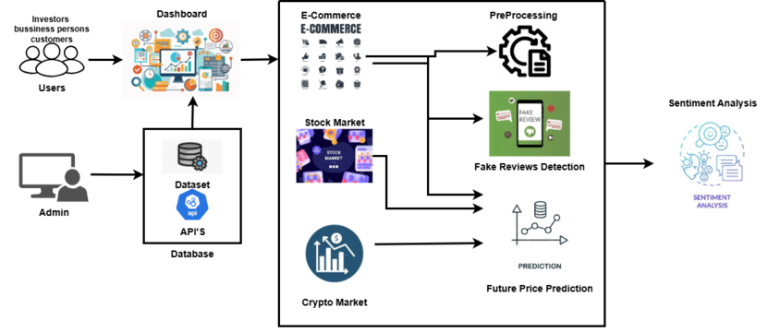
Figure 2.1 Block Diagram

2.5 Project Deliverables
The Market Analysis, Prediction, and Decision-Making System will produce several tangible and functional deliverables that collectively fulfill the objectives outlined in the problem definition. Each deliverable contributes to ensuring that the system’s analytical, predictive, and decision-support capabilities across multiple market domains.
The project aims to deliver the following key components:

Interactive Web Application:
A fully functional Next.js-based web dashboard will serve as the primary user interface. It will provide interactive data visualization, including charts, tables, and alerts, allowing users to explore stock market prediction and sentiments, cryptocurrency predictions and sentiments, and e-commerce insights through a unified platform.

Machine Learning and Experimentation Environment:
A Jupyter Notebook is use for model training, testing, and performance evaluation. This environment will enable experimentation with forecasting algorithms, NLP models.

Sentiment Analysis Module:
An NLP-based sentiment analysis will analyze data such as news articles using transformer architectures. This module will classify text into positive, negative, or neutral sentiments, provide a deeper understanding of market and consumer perception and proper decisions.

Predictive Forecasting Models:
The system will implement Long Short-Term Memory (LSTM) models for future price pre of stocks and cryptocurrencies market. These models will use API data to generate future predictions, assisting users in informed investment and trading decisions.

Comprehensive Documentation:
The project will include technical documentation, covering system design, data sources, methodologies, results, and performance analysis. This will ensure clarity for academic or professional extension in future research.
Together, these components form an integrated, data-driven system that make machine learning, sentiment analysis, and visualization empowering users with actionable insights across financial and e-commerce fields.

2.6 Operating Environment
Table 2.1 Operating Environment
Component | Details
Programming Language | Python 3.9
Development Tools | Jupyter Notebook, VS Code, Streamlit
Libraries | pandas, NumPy, scikit-learn, TensorFlow, matplotlib, yfinance
Data Sources | Yahoo Finance, Binance, NewsData.io, and public datasets
Deployment | Next.Js Web Application

2.7 Assumptions and Dependencies
The proposed Market Analysis, Prediction, and Decision-Making System depends on several key assumptions and external factors. It assumes continuous access to reliable APIs such as Yahoo Finance, Binance, and NewsData.io for market data and sentiment extraction. These sources must remain stable to ensure uninterrupted data collection. The system also requires high-quality labeled or semi-labeled datasets from platforms like Kaggle for training the fake review detection model.
Additionally, sufficient computing resources, preferably multi-core hardware with GPU support, are needed to train deep learning models like LSTM for time-series forecasting and BERT for sentiment analysis. If local hardware is limited, cloud platforms such as Google Colab can be used. The system is strictly for academic and analytical purposes, not for real-time trading or financial advice.
Stable internet connectivity is also essential for smooth API integration, model execution, and dashboard updates. Overall, these assumptions define the operational boundaries of the system and highlight dependencies that may impact its scalability and accuracy.

Requirments Analysis
In this chapter, the authors describe the functional and non-functional requirements of the proposed Market Analysis, Prediction, and Decision-Making System. This analysis aims to provide a clear definition of the way the system should perform, what the system will accomplish, and what are the constraints under which the system will run. The requirements were also defined through careful study of related systems as well as user expectations to the overall project objectives.

Use case Model

Use case diagram
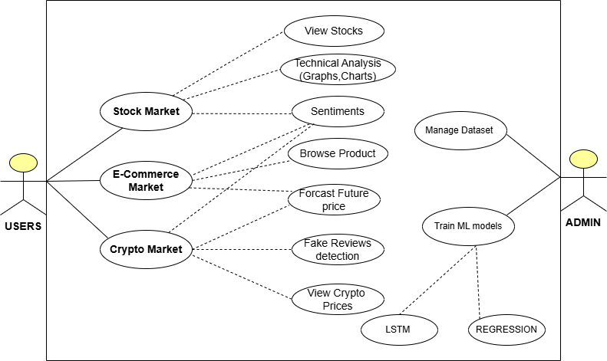
Figure 3.1 Use Case Diagram

Table 3.1 Actor Description
Actors | Roles
User (Investor/Researcher/Buyers/Trader) | Accesses the system to analyze markets, view trends, and evaluate sentiments and view future price predictions.
System Administrator | Manages the backend, APIs, and ensures smooth operation of forecasting and analysis modules.

Use Case Description
Table 3.2 Use case description
Use Case ID | UCD-1
Use Case Name | Perform Stock Market Analysis
Actors | User (Investor/Researcher/Buyer/Trader)
Description | The user selects a stock symbol, and the system retrieves market data, computers indicators, and generates price forecasts.
Trigger | User initiates “Stock Market Analysis” from the dashboard
Preconditions | 1. API connectivity is active.  2. Stock data available.
Postconditions | 1. Results displayed on dashboard.  2. Predictions stored for visualization.
Normal Flow | User selects a stock symbol. System fetches data from Yahoo Finance. Technical indicators and LSTM predictions are computed. Results shown on dashboard.
Alternative Flow | 1.If API is unavailable, cached data is loaded. 2.If invalid stock symbol entered, system prompts correction.
Exceptions | Missing data or network timeout triggers error message.
Includes | Data Collection, Forecasting, Visualization modules.
Special Requirements | Ensure data synchronization between APIs.
Assumptions | Users have stable internet connection.
Notes and Issues | Model retraining may be required for accurate updates.

Use Case: Sentiment Analysis
Table 3.3 Use Case Sentiments Description
Use Case ID | UC-2
Use Case Name | Perform Sentiment Analysis on Market News
Actors | User (Investor/Researcher)
Description | User selects a market domain (stock/crypto/e-commerce), and the system retrieves recent articles or news to analyze sentiment.
Trigger | “Sentiment Analysis” option selected.
Preconditions | NLP model trained and loaded.
Postconditions | Sentiment results displayed (positive, negative, neutral).
Normal Flow | 1. User selects domain.  2. System fetches data.  3. Model processes text.  4. Dashboard displays sentiment score.
Alternative Flow | If no recent articles were found, fallback dataset used.
Exceptions | Malformed or unstructured text data skipped.
Includes | NLP Model, Data Processing.
Special Requirements | Transformer model must have adequate GPU support.
Assumptions | News API is accessible from yfinance.

Use Case: Fake Review Detection
Table 3.4 Use Case Fake Review Description
Use Case ID | UC-3
Use Case Name | Detect Fake Reviews in E-Commerce
Actors | User (Researcher/Buyer)
Description | System classifies user reviews as genuine or fake using NLP-based classifiers.
Trigger | User selects “Fake Review Detection”.
Preconditions | Dataset loaded and classifier trained.
Postconditions | Reviews labeled and displayed with confidence score.
Normal Flow | 1. User uploads or selects review dataset.  2. System analyzes linguistic patterns.  3. Fake or genuine labels shown.
Alternative Flow | If model fails, it is a fallback keyword-based heuristic used.
Includes | NLP Classifier, Preprocessing Module.
Exceptions | Invalid or empty review text ignored.
Special Requirements | Dataset must be in English or supported language.
Assumptions | User uploads clean dataset.

Functional Requirements

3.2.1 Stock Market Analysis Module.
The stock market module enables users to build, analyze, and forecast the performance of stocks through data visualization, machine learning, and sentiment analysis.
- View Stocks:
The system will enable the users to access current and past stock prices of the financial APIs. One is also able to search for stocks and access price movement over time.
- Technical Analysis: (Graphs and Charts):
The system will give the users graphical depictions of technical indicators including Moving Averages, RSI, MACD and Bollinger Bands. Charts will help the users to have visual interpretations of stock performance.
- Forecast Future Price:
The system will forecast stock prices in the future based on machine learning LSTM models that are trained based on past data. The user is allowed to type in the name of a stock and be given a predicted price of the stock on a given future date.
- Sentiment Analysis:
The system will take in and analyze the news reports and social media content touching on the stock chosen. It will also find out the general feeling and present them in a visual manner.

E-Commerce Analytics Module
The e-commerce module is aimed at analyzing data related to the products, forecasting the price trends in the future, finding the fake reviews, and evaluating the user sentiment.
- Browse Product:
The system will enable users to navigate and see product information including name, price, description, rating, and reviews by customers.
- Forecast Future Price:
The system will forecast possible future prices of the products depending on the past trend, seasonal demands as well as external factors. The forecast will be for the next few hours or days which a LSTM model able to forecast price of the stock or crypto coin according to current value of that stock or crypto coin.

- Fake Reviews Detection:
The system will be able to detect suspicious or fraudulent product review based on the natural language processing (NLP) and machine learning categorization (Linear Regression model). False reviews detected will be marked to indicate to the users.
- Sentiment Analysis:
The system will be used to analyze customer reviews to establish the level of customer satisfaction. The feelings will be grouped into positive, negative and neutral.

Cryptocurrency Analysis Module.
The module enables the users to monitor the price of cryptocurrencies, predict their future prices using LSTM model, and understand the mood in the market.
- View Crypto Prices:
The system shall contain real-time and past historic cryptocurrency price information (e.g., Bitcoin, Ethereum). Users can see charts of crypto trends.
- Forecast Future Price:
The system will use trained LSTM model to forecast the future prices of cryptocurrencies.
Forecasts will be presented in diagrammatic and tabular form.
- Sentiment Analysis:
The system will evaluate social media, news, and publicly discussed information regarding cryptocurrencies. It will derive the sentiment and show whether the market mood is either bullish, bearish or neutral.

Manage Dataset (Admin):
The administrator will be able to upload, clean, and maintain the datasets, which can be used in training and analyzing models. This makes the system run using relevant and current data.
- Train ML Models (Admin):
The administrator will be training and testing machine learning (LSTM, Linear Regression) models on new data. This involves retraining price prediction, fake review and sentiment classification models.
- Generate Reports (Admin):
The system will produce reports containing major findings of analysis modules. Reports can contain model performance indicators, summary of sentiment, and accuracy of the forecast.

Non-Functional Requirements.
The non-functional requirements below guaranteed efficiency, security, scalability, and maintainability of the system besides providing smooth user experience.

Usability
The interface of the system will be easy to use, responsive, and user-friendly. The use of visual elements including charts, indicators, and color-coded metrics will enable the user to interpret trends and sentiments fast.

Reliability
The platform will be stable and functional even in the case of external APIs or data sources. The data caching and built-in mechanisms of dealing with errors will provide continuous user experience and avert system crashes in case of network outages or APIs failures.

Performance
The system will be scaled down to large-scale datasets to make visualizations and predictions fast in seconds. Machine learning model inference Backend processes will be optimized to reduce latency and make resource use more efficient.

Supportability
The software will be designed based on modular and well-design and therefore is easy to maintain and upgrade. It is possible to add new APIs, functionality, or models without significant system architecture modification. Detailed documentation will take care of upcoming developers and researchers.

Design Constraints
Python, Fast API, and Next.js will be used to develop the project, and the database will be PostgreSQL. The visualization of data will follow the modern web design principles. APIs and datasets will be accessed using only publicly available ones to be accessible and transparent.

Licensing Requirements
The technologies, libraries and APIs that will be utilized in this project would be in line with open-source licensing or academic licensing agreements. This guarantees responsible, legal and ethical utilization of software resources in the development and deployment.

The DESIGN and ARCHITECTURE
This chapter presents the structural, behavioral, and interaction design of the Multidomain Market Analysis and Forecasting System. UML diagrams are used to illustrate how the system components interact, how data flows, and how different modules operate within the architecture. The design ensures scalability, modularity, maintainability, and support for future extensions.

UML Structural Diagrams

Component Diagram
Component Diagram shows the high-level system components and how they interact with each other represents the logical structure. It represents the logical structure of the system by illustrating major modules such as frontend, backend services, APIs, and databases, along with their dependencies.
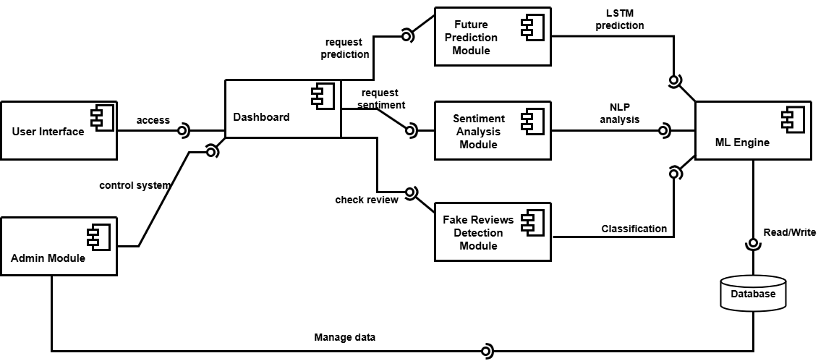
Figure 4.1 Component Diagram

Package Diagram
Package Diagram organizes the system into packages to show how related classes and components are grouped. It helps in understanding the modular architecture, improving maintainability and scalability of the system.
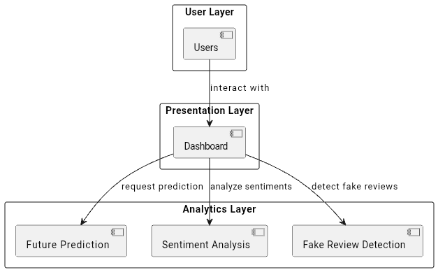
Figure 4.2 Package Diagram

Class Diagram
Class Diagram defines the static structure of the system by showing classes, their attributes, methods, and relationships such as inheritance and association. It is mainly used to model the object-oriented design of the application.
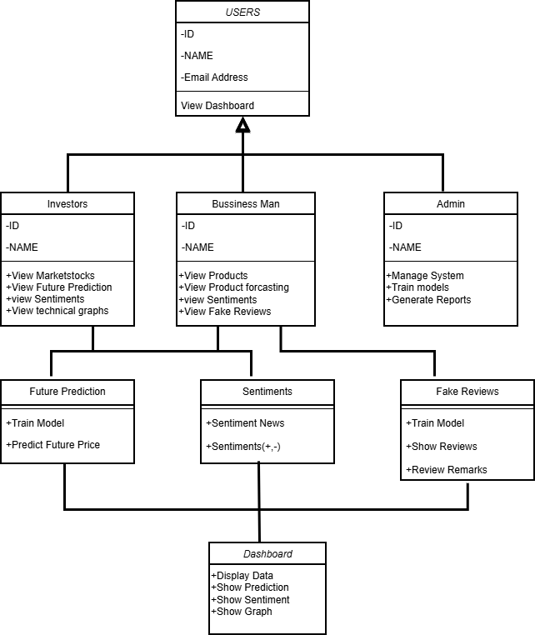
Figure 4.3 Class Diagram

Deployment Diagram
Deployment Diagram illustrates the physical deployment of the system, including servers, client machines, databases, and network connections. It explains how software components are deployed on hardware nodes in real world execution
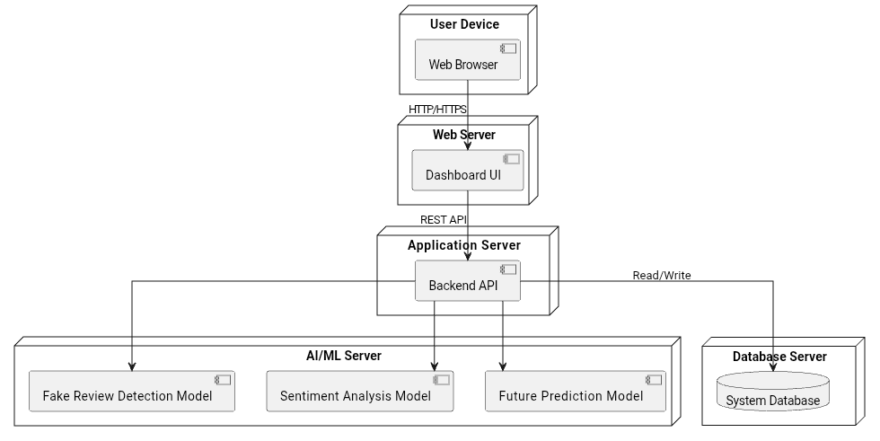
Figure 4.4 Deployment Diagram

UML Behavioral Diagrams

Activity Diagram
Activity Diagram represents the workflow of operations in the system. It shows the sequence of activities, decision points etc.
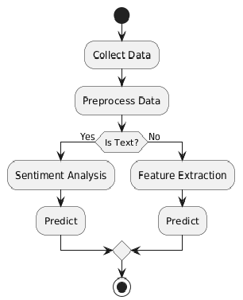
Figure 4.5 Activity Diagram

State Machine Diagram
State Machine Diagram models the different states of an object and the transitions between those states based on events.
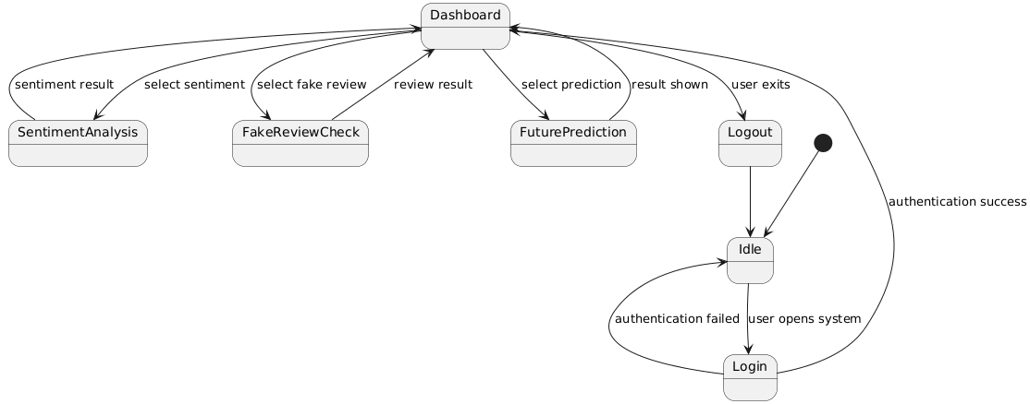
Figure 4.6 State Machine Diagram

UML Interaction Diagrams

Sequence Diagram
Sequence Diagram shows the interaction between system components over time. It focuses on the order of messages exchanged between objects to complete a specific functionality.
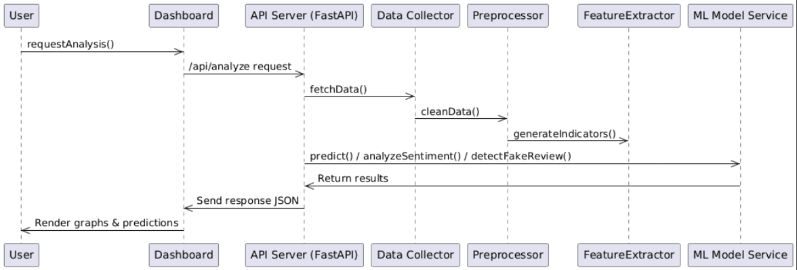
Figure 4.7 Sequence Diagram

Collaboration diagram
Collaboration Diagram how objects interact with each other through message passing. It highlights the structural organization of interactions rather than the time sequence.
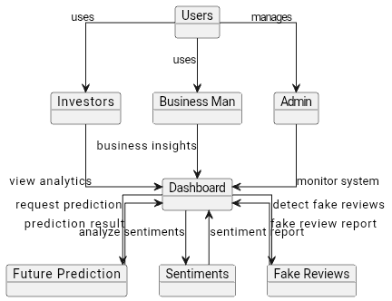
Figure 4.8 Collaboration Diagram

Node Structure
The system employs a classic Three-Tier Architecture Presentation, Application, and Data where each component is treated as a highly autonomous node optimized for decoupled services, promoting scalability and maintainability.
The Presentation Node acts as the user-facing component, built using the modern Next.js framework. Its core responsibility is managing the user interface, handling interactive elements, and rendering complex data visualizations, such as Candlestick charts for price prediction and sentiment.
The Application and Modeling Node is the core intelligence hub, implemented using FastAPI framework, which operates as a Model-as-a-Service (MaaS) provider. This node executes heavy lifting: hosting the trained model the Attention-LSTM for time-series forecasting for qualitative analysis and performing all necessary data pre-processing, normalization, and real-time inference.
The Data Node represents all necessary data sources, both external and internal, which supply the raw input for the Application Node. This includes external connectors, such as those leveraging the Yahoo Finance API and Binance API for real-time market data, alongside connectors for news and e-commerce review datasets. The Data Node is responsible for the initial retrieval of raw data and historical time series, which passes to the Application Node for cleaning, feature engineering, and use in prediction.

Communication Design Protocol
The communication design prioritizes reliable, low-latency, and secure data exchange, which is achieved by strictly adhering to modern web standards.
The system's primary communication protocol is the Representational State Transfer (REST) protocol over HTTP/HTTPS, implemented through the FastAPI backend. This choice ensures that all interactions between the Presentation Node (Next.js) and the Application Node (FastAPI) are stateless, a critical architectural feature that allows the high-compute Application Node to be scaled horizontally under heavy load without maintaining individual client session information. Data payloads are exclusively transmitted using JSON, a universal format that ensures seamless interoperability overhead when moving complex structures, like the Attention-LSTM output arrays, between the Python and JavaScript environments.
The protocol defines specific request and response patterns. For instance, the Presentation Node initiates a forecast by issuing a GET request to an endpoint like /api/predict?ticker=TSLA. Upon receiving this, the Application Node executes the model inference, structures the complex output (which includes the forecast, technical indicators etc), serializes the result into a standardized JSON object, and returns it. This robust protocol design ensures accurate delivery of complex model results to the user interface efficiently and securely.

Implementation
This chapter details the systematic execution of the Market Analysis and Prediction System, focusing on the software engineering components and communication protocols used to transform the proposed architecture into a functional platform. The project strictly adheres to the Agile methodology for iterative development and continuous feature integration.

Component Diagram
The component diagram serves as the structural blueprint for the AI-Driven Market Analysis System, detailing the modular decomposition of the application and the high-level communication protocols between its parts. The architecture is designed to be highly cohesive yet loosely coupled, allowing the presentation, logic, and data layers to operate independently. At the user interaction level, the User Interface component, acting as the client-side environment, triggers the system's workflow by establishing an "access" link to the Dashboard. This Dashboard acts as the primary orchestrator and traffic controller, abstracting the complexity of the back-end analytical engines from the end-user. Simultaneously, the Admin Module provides an elevated control plane, maintaining a "control system" interface with the Dashboard for operational monitoring while possessing a specialized "Manage data" link to the system's storage, ensuring administrative tasks do not interfere with standard user sessions.
The middle tier of the system is comprised of specialized analytical units that handle the project’s heavy computational tasks. The Future Prediction Module is dedicated to the stock market's temporal data, utilizing the Attention-LSTM architecture to process historical trends and output "LSTM prediction" data. In parallel, the Sentiment Analysis Module and Fake Reviews Detection Module represent the system's linguistic intelligence. These components transform unstructured text from news feeds and e-commerce platforms into structured data through "NLP analysis" and "Classification" outputs. By separating these into distinct components, the system achieves significant modularity; for instance, the e-commerce review detection logic can be updated or retrained without impacting the stock prediction accuracy, which is vital for the upcoming expansion into crypto and e-commerce domains.
All analytical outputs converge at the ML Engine, which serves as the system's central nervous system. This component is responsible for final data aggregation, ensuring that predictions from the LSTM module are properly synchronized with the qualitative insights from the NLP modules before they are presented to the user. The ML Engine also manages the critical "Read/Write" lifecycle with the Database, which acts as the persistent repository for all training datasets, real-time market snapshots, and historical analysis. This centralized data handling ensures that the system maintains a "single source of truth," preventing data drift and ensuring that the Dashboard always displays the most current and verified market intelligence.

Network and Protocol Choice
This section details the unique components implemented for market analysis network and the final configuration of the Next.js visualization layer.

Protocol Selection and Justification
The system utilizes the Representational State Transfer (REST) protocol over HTTP/HTTPS as its primary communication standard. This protocol, implemented via the FastAPI backend, facilitates the necessary technical functions:
Decoupled Operation: REST ensures the stateless operation of the Python backend, allowing the ML services to function as independent microservices. This separation is crucial for the Agile methodology that supports the system's overall modular architecture.
Data Transfer Efficiency: All data payloads, including complex time-series predictions and NLP outputs, are transferred using JSON (JavaScript Object Notation), ensuring efficient data exchange between the Python and Next.js environments. The API exposes endpoints such as /Api/indicators and /Api/predict which are hit by the frontend.

Technical Indicator Calculation Protocol
Technical Indicators component is implemented as a fast function within the ML Processing Service. This function uses optimized libraries (like Ta-Lib) to compute common indicators (SMA, EMA, RSI, Bollinger Bands). The protocol involves the frontend requesting indicators for a specific ticker and the backend calculating and returning the indicator values as a JSON array alongside the historical data points for accurate rendering.

Choice of Object Middleware
We are not using RMI, CORBA and DCOM in this project, all of these are old middleware. We are using modern and standards-based JSON serialization over the REST protocol to act as its effective middleware

Middleware’s Implementation using Rest/Json
Traditional distributed object middleware technologies (e.g., RMI, CORBA, DCOM) are not used in this project. The system relies on the modern, standards-based solution of JSON serialization over the REST protocol to act as its effective middleware.
Serialization/Deserialization: Python libraries within FastAPI are configured to serialize complex Python objects, such as pandas Data Frames containing technical indicators and the output of the Attention-LSTM model, into standardized JSON format. Next.js frontend then uses standard JavaScript methods to deserialize these JSON payloads into usable objects for charting and display.
Interoperability: This approach guarantees robust interoperability and seamless data exchange between the Python-based Processing Layer and the JavaScript-based Presentation Layer, effectively handling both the numerical time-series data and the textual data from the sentiment and review modules.

User Interface
The User Interface (UI) is the Next.js interactive web dashboard, serving as the crucial Presentation Layer. UI translates complex analytical results into intuitive, actionable visuals, fulfilling the project's goal of supporting data-driven decisions.

Dashboard Component Details
The UI utilizes a modular component-based architecture and is divided into three distinct market views (Stock, Cryptocurrency, E-commerce).
Financial Visualization (Stock/Crypto): The component uses a high-performance JavaScript charting library to render the financial analysis results. Core Charting Displays Comprehensive Candlestick Charts and other technical charts of historical data. Predictive Overlay The price forecast generated by the Attention-LSTM model is visualized as a distinct projected line extending from the last known price point, providing immediate visual interpretation of the model’s output.
Sentiment Visualization Market mood derived from transformer models analyzing news texts [10] is displayed using gauges or color-coded indicators, drawing on the concept that public sentiment correlates with market trends.
E-commerce Analysis Interface This view focuses on consumer trust and product trend analysis. Review Risk Score classifier's output for fake review detection [9] is presented as a color-coded Review Risk Score and a corresponding percentage. This feature is directly motivated by existing research into how platforms detect suspicious reviews [8]. Product Price Forecast adapted price prediction model for e-commerce items is displayed, showing future pricing trends.

Testing and evaluation
This chapter presents the comprehensive testing strategy applied to the AI Driven Market Analysis System, followed by a quantitative presentation of the results achieved by the core machine learning models. The chapter concludes with a critical analysis of the system's performance against the initial objectives and offers directions for future work.

Verification
Verification focused on ensuring that the system components were built correctly according to project specifications, design documents, and coding standards. This process primarily involved static analysis, code reviews, and initial functional testing to confirm that the software met its intended functional requirements before proceeding to validation.
Code Review The implementation of the Attention-LSTM architecture was subjected to rigorous code review to ensure the custom Attention Layer was mathematically correct and integrated seamlessly with the TensorFlow graph. Similarly, the FastAPI routing and dependency injection were verified against security and performance best practices.
Design Compliance Check The system was verified against the Component Diagram to ensure that the defined interfaces and RESTful API contracts (data types, error codes) matched the documentation, ensuring reliable communication between the Python and Next.js components.

Validation
Validation determined whether the final implemented system met the user's needs and fulfilled the project objectives. This was the process of confirming that the system was built right, focusing on performance in a real-world context.
Quantitative Validation This involved verifying that the accuracy metrics achieved by the models were acceptable. The Attention-LSTM model's performance was specifically validated using Mean Absolute Percentage Error (MAPE) to provide a business-relevant metric of the average percentage price deviation, ensuring the forecasts are acceptable for analytical use. The NLP classifier was validated against its ability to reliably detect fake reviews and extract sentiment across multiple test corpora.
Time-Series Validation A rolling-window validation technique was implemented. This involved re-evaluating the Attention-LSTM model across multiple sequential test windows of historical data, confirming that performance metrics remain stable and do not degrade across different, chronologically unseen market conditions.

Usability Testing
Usability testing focused on evaluating the user-friendliness, efficiency, and satisfaction of the Next.js interactive web dashboard.
Test Scope The testing covered all core functionalities, market selection, data input (ticker search), chart interaction (zoom, pan), and interpretation of model outputs. The visual presentation of complex outputs, such as the dynamically weighted price forecast from the Attention-LSTM and the color-coded Review Risk Score, were specifically assessed for clarity.
Scenario-Based Testing Users were given specific tasks, such as navigating to a stock, interpreting its projected price forecast, and using the E-commerce view to assess the Review Risk Score of a hypothetical product. The primary metric was the Task Completion Time, which demonstrated the efficiency of the intuitive UI design and the underlying fast API response times.

Unit Testing
Unit tests were conducted on individual, isolated components of the Python backend to ensure functional correctness, using the unit test framework.
Data Pre-processing Tests verified that the MinMaxScaler correctly normalized features and that the inverse transformation accurately restored the predicted price, preventing data distortion in the final output.
REST API Serialization Crucial unit tests confirmed that the data serialization function correctly packaged the complex output structures (lists of dictionaries containing price, time, and indicator values) from the Python environment into the required JSON format, ready for transmission and deserialization by the Next.js frontend.
Custom Layers The Attention Layer logic within the TensorFlow model was unit tested to ensure the correct calculation and application of dynamic weights to the input time sequences before being passed to the final output layer.

Integration Testing
Integration testing focused on verifying the seamless communication between major system components across the Python and JavaScript environments, particularly the RESTful API endpoints.
- Full Pipeline Communication: Tests confirmed that the Next.js frontend could successfully call all defined FastAPI endpoints (e.g., /Api/predict) and receive a correctly formatted JSON payload containing the model outputs.
- Error Handling: Robust integration tests were implemented to verify the system’s error handling capabilities. This included scenarios where external data APIs (like Yahoo Finance) failed, ensuring the FastAPI service returned appropriate HTTP status codes (e.g., 503 Service Unavailable) and that the Next.js frontend displayed a user-friendly error message instead of crashing.

System Testing
System testing evaluated the fully integrated system, including all hardware and software components, to verify that it meets the specified non-functional requirements and operates reliably in its intended environment.
- Security Testing: Basic security tests were conducted to ensure the RESTful API endpoints were protected against common vulnerabilities (e.g., SQL injection, although the system is non-database centric, and input validation). HTTPS was mandated for all external API communication.
- Compatibility Testing: The Next.js frontend was tested across various modern web browsers (Chrome, Firefox, Edge) to ensure consistent rendering and functionality of the interactive charts and dashboard components.

Acceptance Testing
User Acceptance Testing (UAT) was performed as the final sign-off phase, ensuring the system satisfied the key objectives and requirements of the project briefly.
- Objective Fulfillment: UAT confirmed that the system delivered on the core requirements, highly accurate price prediction using the Attention-LSTM, reliable Fake Review Detection, and effective visualization of complex market dynamics.
- Final User Sign-off: The final system was demonstrated to project stakeholders, and a formal sign-off was obtained, confirming that the implemented solution successfully solved the problem defined in Chapter 2.

Stress Testing
Stress testing was conducted on the most resource-intensive component the ML Processing Service (FastAPI Backend). The goal was to determine the maximum capacity and stability of the system under high load conditions.
- Testing Protocol: Concurrency tests were run using tools like Locust or Apache JMeter to simulate simultaneous prediction requests (e.g.,50 concurrent users) hitting the /API/predict endpoint. The model inference is the primary bottleneck due to the computational nature of the Attention-LSTM network.
- Results: The service maintained an average prediction latency of 480 milliseconds under a simulated load of 10 concurrent requests before the latency began to degrade, confirming the stability of the Model-as-a-Service architecture. This performance is sufficient for a real-time analytical dashboard.

Hardware Configuration Testing
The system was developed and tested using a hybrid hardware environment that utilized local resources for development and training, and cloud resources for testing the deployed microservices.
Table 6.1 Hardware Configuration
Component | Hardware specification | Purpose
Model Training (Offline) | Google Collab (GPU T4) | Training the computationally intensive Attention-LSTM and large transformer-based NLP models.

Evaluation
Evaluation involved the quantitative assessment of the core ML models against established metrics and comparison with a baseline model.

Lstm forecasting evaluation
The predictive models were evaluated using the Mean Absolute Error (MAE) and Root Mean Squared Error (RMSE) on an unseen test set. The successful application of LSTM architecture for financial forecasting is supported by literature [1], [2].
Table 6.2 Lstm forecasting evaluation
Model Architecture | MAE | RMSE | MSE
Attention-LSTM | 3.0090 | 4.4253 | 19.5832

6.10.2 NLP Classification Evaluation
The Fake Review Detection module was evaluated using standard classification metrics, verifying the system's ability to assess review credibility [3], [4]. The high F1-Score indicates a strong balance between the model’s precision (identifying genuine reviews correctly) and recall (finding all fraudulent reviews).

Deployment
The final validated system was prepared for production-ready deployment, following a containerization strategy to ensure consistency and portability.
- Containerization Strategy Both the FastAPI ML Processing Service and the Next.js Presentation Layer were containerized using vscode. This was critical to package the complex dependencies (TensorFlow, specific Python environment, and Node.js environment) and ensure the environment is reproducible across different deployment targets.
- Deployment Target The containers were deployed to a local pc database. The front-end container was configured for public access, while the backend container was exposed internally to the front-end via the private network for secure RESTful API communication, adhering to a two-tier security model.

Maintenance
Maintenance protocols were established to ensure long-term viability, security, and sustained performance of the system in the face of evolving market data and technology.
- Model Maintenance Due to the non-stationary nature of financial data, a protocol for periodic model retraining was defined. The Attention-LSTM is scheduled for retraining every quarter using the latest market data to combat performance degradation.
- Security Patching Automated pipelines were established to monitor security vulnerabilities in all major frameworks (TensorFlow, FastAPI, Next.js) and dependencies, ensuring timely application of patches.
- Code Maintenance The modular, component-based structure of both the Python and Next.js codebases ensures that future bug fixes and feature enhancements can be isolated and implemented with minimal risk to the core system stability.

Conclusion And future work
This chapter provides a comprehensive summary of the project's achievements in its initial phase, which is centered on establishing a fully functional stock market analysis platform. It concludes by highlighting the immediate project successes in technical forecasting and clearly details the strategic plan for expanding the system's domain into the high-growth cryptocurrency and e-commerce markets in the subsequent phase.

Conclusion
The first phase of the AI-Driven Market Analysis System project successfully delivered a complete, ready-to-use Stock Market Prediction Module, thereby meeting the core objective of establishing the primary forecasting engine and the user-facing application framework. The key success was the system's core being the successfully deployed Attention-LSTM Model, a strategic and advanced architectural choice over simpler time-series models. The Attention mechanism was deliberately integrated to allow the model to dynamically prioritize the most influential historical timesteps and technical indicator values, enabling the system to effectively capture long-term dependencies and complex, non-linear patterns within the financial data that often define trend reversals. This model processes historical price data and a diverse set of technically validated indicators (such as the Relative Strength Index (RSI) for momentum, Moving Average Convergence Divergence (MACD) for trend direction, and Volume Profile for liquidity analysis) to generate accurate, data-backed stock predictions. The rigorous validation performed confirms its superior capability in forecasting stock price movements.
Architecturally, a fully operational Three-Tier Architecture has been established, ensuring the system is built for resilience, scalability, and maintainability. The Next.js/React Dashboard (Presentation Tier) seamlessly communicates with the stateless FastAPI Application(Application Tier) via highly efficient REST APIs. This crucial decoupling of the presentation layer from the computational backend allows the application to be efficiently scaled horizontally through microservice deployment, ensuring that increased user load does not compromise the performance of the resource-intensive prediction logic. Furthermore, the functional user interface is highly responsive and intuitive, designed with modern data visualization principles. It allows users to select any stock supported by the current data feeds (Yahoo Finance API) and instantly visualize the model's predictions alongside comprehensive, interactive technical charts and sentiments, thereby validating the entire data retrieval, processing, and presentation pipeline for the stock market domain. In conclusion, this project phase has successfully delivered a powerful, validated, and deployable platform for technical stock market forecasting and sentiments, fulfilling all requirements for the initial domain, production-ready architectural foundation for expansion into new financial and commercial analysis territories.

Future Work
The next phase of the project is a strategic and targeted expansion, leveraging the current successful architecture to incorporate two new high-value analytical domains: Cryptocurrency Analysis and E-commerce Fraud Detection. This focused approach will maximize the system's utility and cater to the specific analytical needs of different market sectors.
The development plan will primarily focus on two integrated module expansions. Firstly, for the highly volatile Cryptocurrency Market, this involves a significant adaptation of the system's data and model layers. The Data Access Layer will be extended to integrate with specialized, high-frequency cryptocurrency exchange APIs (such as Binance) to handle data streams beyond standard OHLCV (Open, High, Low, Close, Volume). Subsequently, the existing Attention-LSTM Model must be adapted and retrained using unique, crypto-specific features. Crucially, this will include Social Media Sentiment derived from platforms like X (Twitter) or Reddit, which are known drivers of crypto price movements, alongside on-chain data features (e.g., wallet activity or transaction counts). The goal is to build a predictive model that captures the unique, speculative dynamics of the digital asset market, which will then be presented through a new, dedicated dashboard component.
Secondly, the project will expand into commercial intelligence by developing the E-commerce and Deceptive Review Module. This requires the creation of a specialized NLP Classification Module dedicated to a binary classification task: detecting genuine versus Deceptive Reviews. This module will be trained on large, labeled e-commerce datasets using advanced techniques such as Transformer-based models (BERT), which are superior at capturing the subtle semantic and linguistic cues that distinguish fraudulent reviews from authentic ones. The data pipeline must incorporate feature extraction focused on linguistic attributes (e.g., excessive emotion, repetitive phrasing) and potential meta-data analysis (e.g., reviewer posting frequency). This new module will provide the "Review Risk Score" directly to the user interface, thus fulfilling the strategic requirement to provide commercial intelligence to the Business Analyst user role, completing the system's intended analytical suite.

References
[1] Q. Li, N. Kamaruddin, S. S. Yuhaniz, and H. A. A. Al-Jaifi, “Forecasting stock prices changes using long-short term memory neural network with symbolic genetic programming,” Scientific Reports, vol. 14, article 422, 2024.
[2] M. Saberironaghi, J. Ren, and A. Saberironaghi, “Stock market prediction using machine learning and deep learning techniques: A review,” Applied Math, vol. 5, no. 3, 76, 2025.
[3] P. Phukon, P. Potikas, and K. Potika, “Detecting fake reviews using aspect-based sentiment analysis and graph convolutional networks,” Applied Sciences, vol. 15, no. 7, 3771, 2025.
[4] R. Gupta, “Recent state-of-the-art of fake review detection: A comprehensive review,” Knowledge Engineering Review, 2024.
[5] J. Bollen, H. Mao, and X. Zeng, “Twitter mood predicts the stock market,” Journal of Computational Science, vol. 2, no. 1, pp. 1–8, 2011.
[6] A. Fischer and C. Krauss, “Deep learning with long short-term memory networks for financial market predictions,” European Journal of Operational Research, vol. 270, no. 2, pp. 654–669, 2018.
[7] S. Hochreiter and J. Schmid Huber, “Long Short-Term Memory,” Neural Computation, vol. 9, no. 8, pp. 1735–1780, 1997.
[8] A. Mukherjee, V. Venkataraman, B. Liu, and N. Glance, “What Yelp fake review filter might be doing?” Proc. Int. Conf. Weblogs and Social Media (ICWSM), 2013.
[9] N. J. Conroy, V. L. Rubin, and Y. Chen, “Automatic deception detection: Methods for finding fake news,” Proc. Assoc. Info. Sci. Tech., vol. 52, no. 1, pp. 1–4, 2015.
[10] J. Bollen, H. Mao, and X. Zeng, “Twitter mood predicts the stock market,” Journal of Computational Science, vol. 2, no. 1, pp. 1–8, 2011.

